

Oracle Reverse Smart Connector

Installation & Run Guide

Version 1.0

# 

Table of Contents

1. Introduction 3

1.1 Overview 3

1.2 Scope 3

1.3 Supported Operating Systems 3

2. Pre-requisites 3

2.1 Server Level Access 3

2.2 Erwin DIS User Access 3

3. Installing the Connector 3

3.1 Steps to be performed on the server 3

3.2 Steps to be performed on Erwin DIS Application 6

4. Run Guide 7

4.1 Connector Options 7

4.2 Configuring the Connector 8

4.3 Running the Connector 8

1. Introduction
   1. Overview

The Oracle Reverse Smart Connector is used to reverse engineer SQL objects(packages, functions, stored procedures and views) and create mappings in Erwin Data Intelligence Suite (DIS).

This document aims to provide the steps to be followed to deploy the Oracle connector to an existing DIS instance.

The operation consists of two parts.

1. Placing the required supporting files in the required locations on the server where DIS is installed
2. Importing the connector into the Automation Framework module using the Import Connector functionality of DIS
   1. Scope

* Installation of required supporting files in the DIS Server.
* Importing the connector into Erwin DIS
  1. Supported Operating Systems
* Windows
* Linux

# 

1. Pre-requisites
   1. Server Level Access

* The installation of the connector files is to be done on the server where DIS has been installed
* The user performing the connector install should have access to modify files in the directory where tomcat is installed. The user may require Administrator/root access to modify files depending on the tomcat installation location
* The Connector files shared as part of the deployment package should be placed on the server where DIS is configured for easy access
* Note: The Tomcat service will need to be shutdown for the duration of the connector install. The applications running on the Tomcat server will be down temporarily till the service is started again
  1. Erwin DIS User Access
* The user performing the import of the connector should have access to the Automation Framework Module in DIS

1. Installing the Connector
   1. Steps to be performed on the server

* Check if the user logged into the system has access to modify files in the tomcat installation path and has permissions to stop the Tomcat service
* Make sure the deployment package shared by Erwin contains a folder with the supporting jar files
* Stop the Tomcat service if it is already running, follow the steps below to stop tomcat based on the operating system
  + Windows System
    - Click on the start button at the bottom left corner of the screen
    - In the search bar, type in “Services” and locate the Services Application in the results

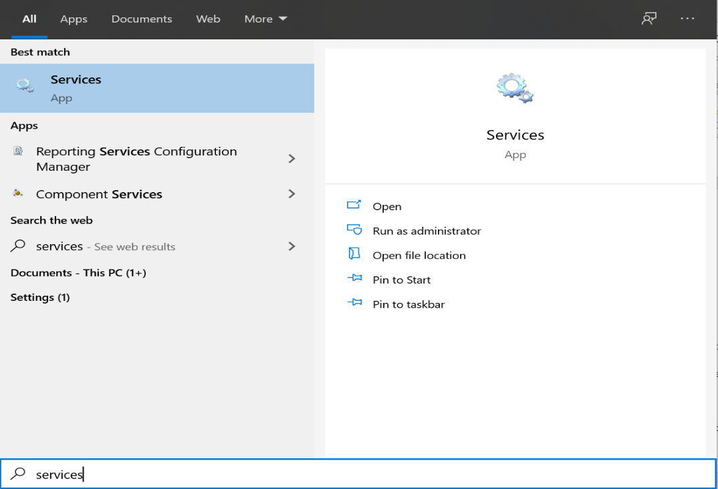

* + - Open the Services Application and find the “Apache Tomcat” service in the list of services

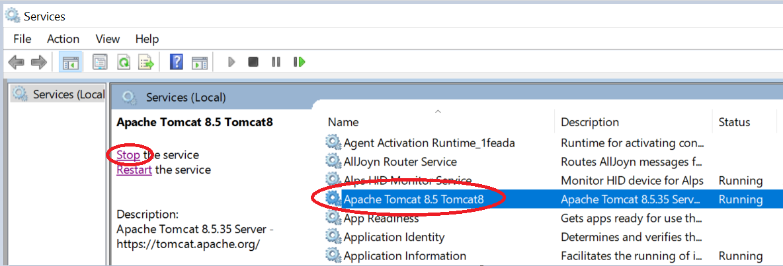

* + - Click on the service and then click on the Stop the service option to stop the Tomcat Service.
* Once the service is shutdown, open and clear the logs folder in the tomcat directory by deleting the log files
* Identify the application path for the DIS instance in tomcat, the application folder will be present in the webapps folder of tomcat.
* The generic path to the lib directory on the DIS instance is as follows:
  + *\*tomcat installation directory\**/webapps/*\*erwinDIS directory\**/WEB-INF/lib
* Copy all the supporting jar files from the deployment package shared by Erwin and place the files in the lib directory of the DIS instance

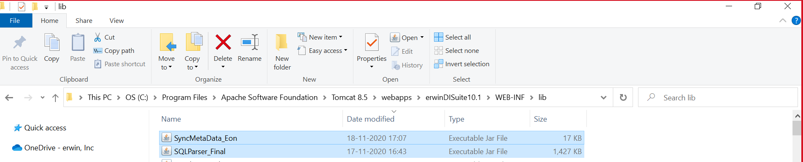

* After the files are copied into the lib directory, restart the Tomcat server.
  + Windows
    - On the services app, click on the Apache Tomcat service and click on the “Start the service” link

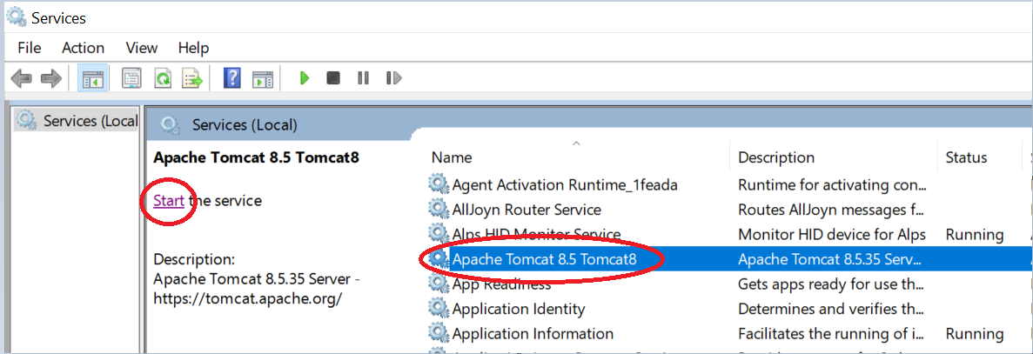

* 1. Steps to be performed on Erwin DIS Application
* Check if the Deployment package shared by Erwin has a folder containing .acp files. We will need those files to be imported into the DIS application to run the Informatica Connector
* Login to Erwin DIS application with a user who has access to the “Automation Framework” module.
* Click on the tile icon on the top left corner of the screen and navigate to the Automation Framework Module

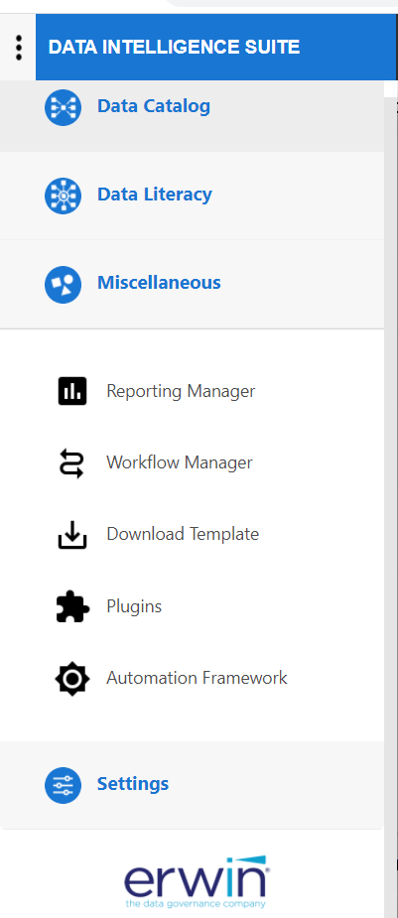

* Here under the CATs tab, we need to click on the Import Template option at the far right of the page and select the .acp file from the deployment package.

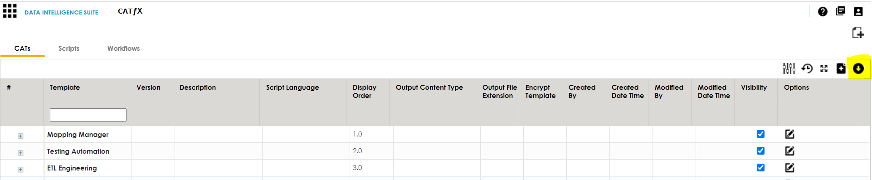

* In the pop-up window, click on the “Override with existing” option. This will replace any older version of the connector if already present on the DIS.

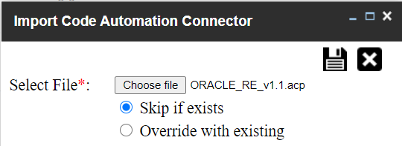

* Click on the “Save” icon on the top right of the pop-up window to finish the import process.
* Refresh the page and Check for the oracle reverse connector template under SQL Reverse Group



The connector has now been successfully installed onto the DIS instance, refer to the User Guide for the connector to understand the configuration options and steps to run the connector.

For any questions regarding the installation process please reach out to the Erwin team.

1. Run Guide
   1. Connector Options

The Oracle Reverse connector provides the following options:

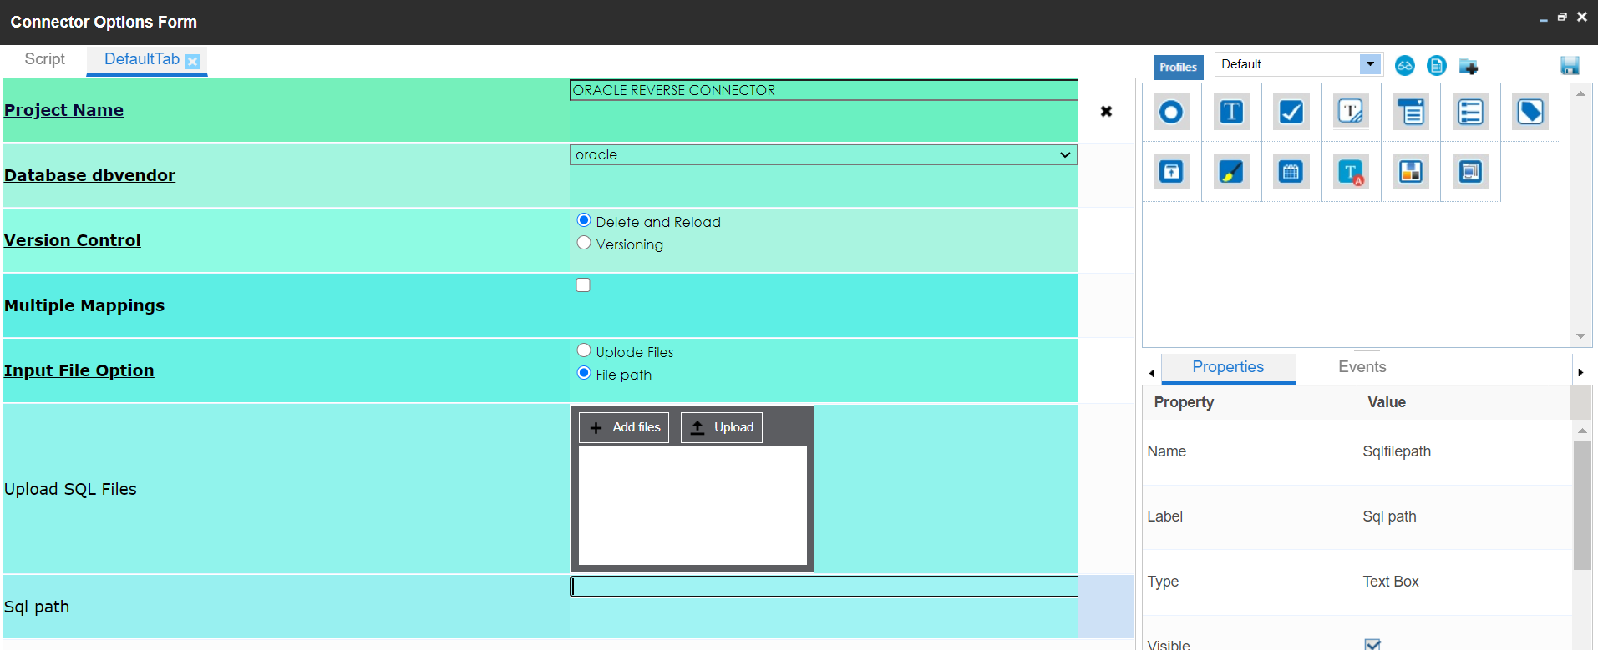

|  |  |
| --- | --- |
| Project Name | This field contains the name of the Project to be used in DIS.  If a project does not already exist, the Connector will create a new project.  If an existing project name is used, the connector will create the  mappings in the existing project. |
| Upload SQL Files | Here need to upload the Oracle Stored procedures. |

* 1. Configuring the Connector

The field details for the connector can be updated by right clicking on the connector and clicking on “Options”, or by clicking on the gear icon under the Options column alongside the connector name.

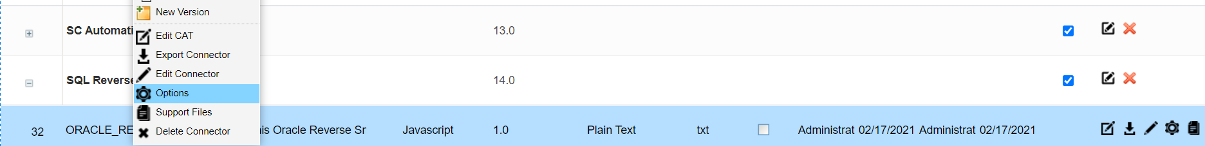

* The values specified in these fields determine the directory paths which the connector will use to pick the input files.
* The Project Name field can contain the name of the Project to be used to create the mappings in. In case an existing project is not available, the connector will create a new project.
* All the above fields can also be edited at runtime.

Remember to click on the save button after making any updates to the Connector options

* 1. Running the Connector

The connector can be executed by following the steps below:

* Right click on the Project node in DIS Mapping Manager and click on “Run Template”.

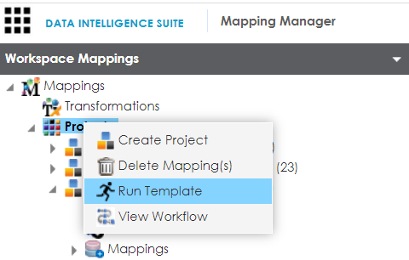

* On the next pop up window Navigate to the Tab “Oracle Reverse” and locate the connector “SQL Reverse” in the Connector List and click on “Export”.

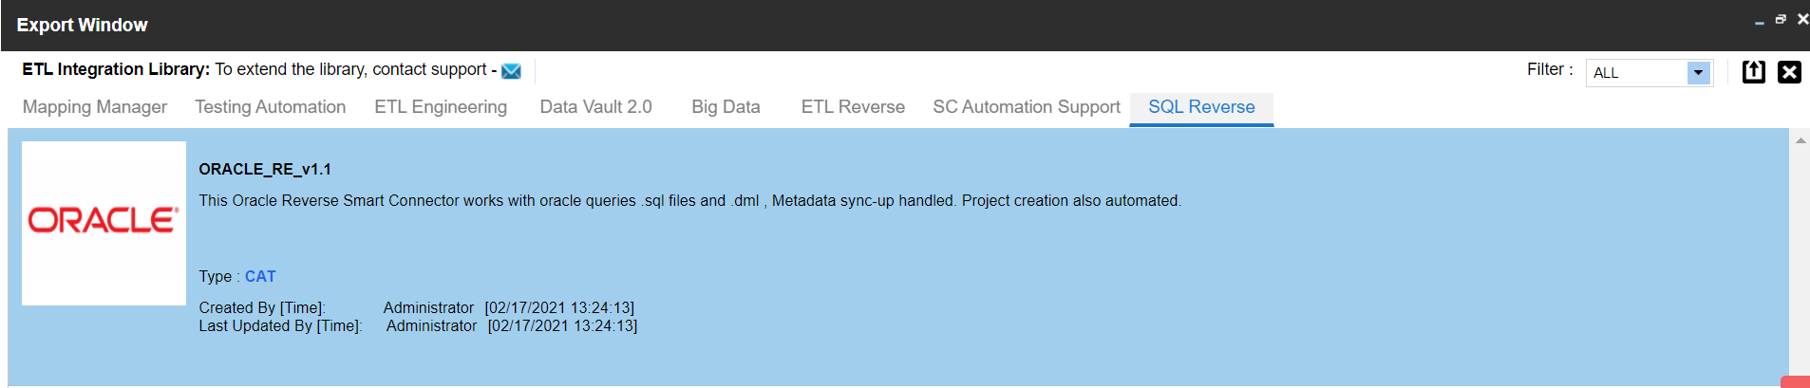

* On the next pop up window, enter the required in the text fields as per the field descriptions in the section “3.2 Connector Options”.
* Click on the green box in the top right corner to run the connector.

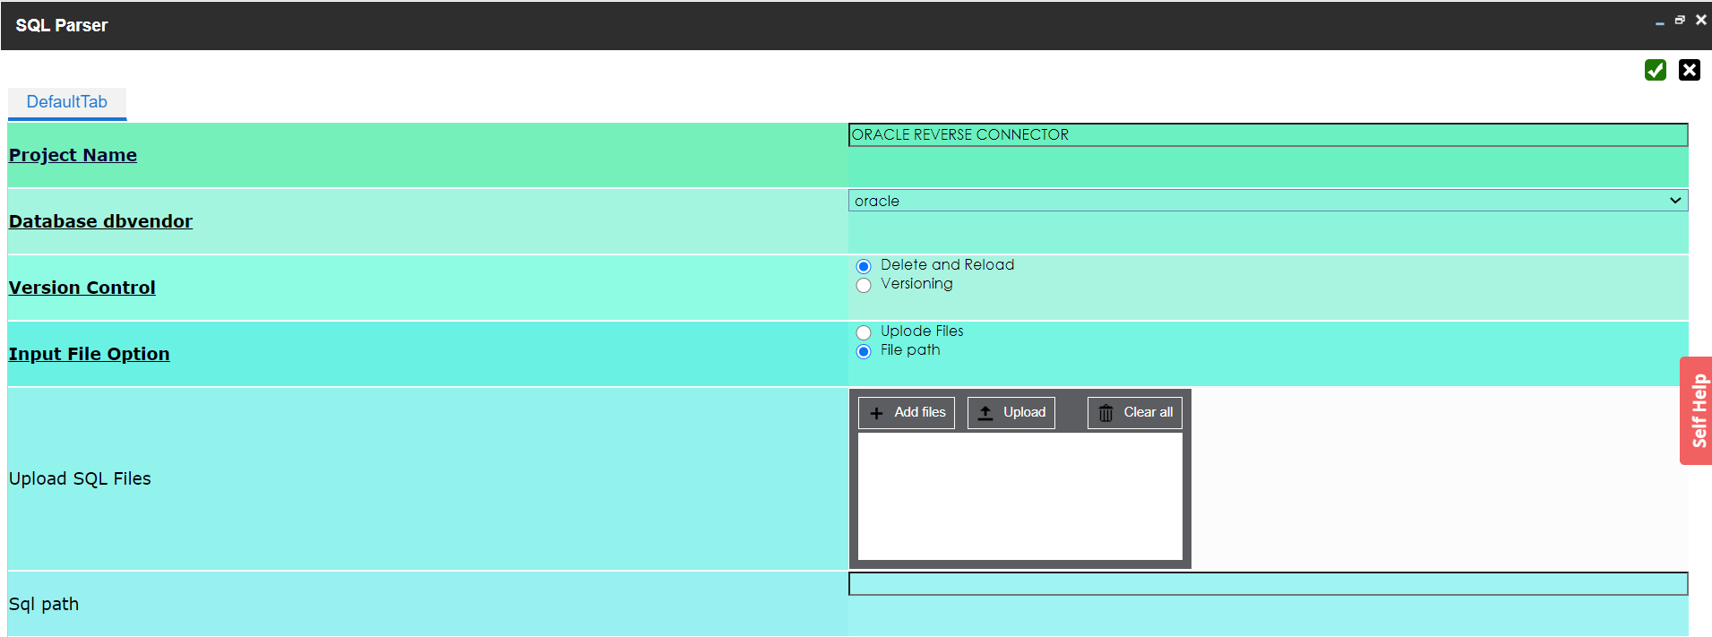

Click on Add Files option, and once its selected, click on upload.

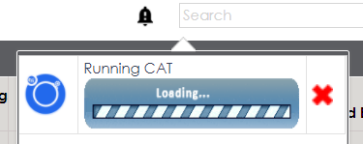

* Once the connector finishes execution, it provides a “Download File” option in the notifications pane.

This file will contain an information log on the mappings created/updated in DIS Mapping Manager.

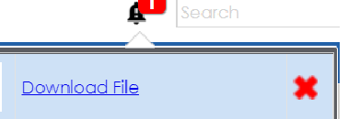

* Refresh the browser window and under the Mapping Manager module, check for the project created on the left-hand side of the page under the Projects Node and verify if the mappings are created.

